**STRUCTURE OF MY REVIEW PAPER:**

**TITLE:**

**ABSTRACT:**

* keywords

**INTRODUCTION:**

* History of SLAM
* About SLAM
* About VSLAM
* About Algorithms, types of cameras, and approaches
* Discuss of each section that is included

**SYSTEM SETUP:**

**Here, we can discuss the hardware and software requirements**

**FORMULATION:**

**VISUAL SLAM PARADIGAM:**

* Pattern of VSLAM
* Data acquisition and system initialization
* System Localization
* System map formation
* System loop closure and process tuning
* Diagram of process

**METHODOLOGY:**

* Visual SLAM Methods
* Explanation of each method
* About camera and types
* Comparison of table

**DATASETS:**

* History of VSLAM datasets
* Explain every dataset
* And also mentioned the environment conditions
* And which dataset is suitable for different environments

**RESULTS:**

* Comparison of different parameters
* We can create a table

**OPEN PROBLEMS (CHALLENGES):**

**CONCLUSIONS:**

**ENDNOTES:**

Paste the code on the GitHub link

**REFERENCES:**

|  |  |  |  |  |  |
| --- | --- | --- | --- | --- | --- |
| **DATASET** | **SENSOR** | | | **ENVIRONMENT** | |
| Monocular | Stereo | RGB-D | Indoor | Outdoor |
| EuRoC-MAV | Yes  Yes  Yes | Yes  -  Yes | -  -  Yes | Yes  Yes  - | -  -  Yes |
| TUM RGB-D |
| KITTI |

Fig 02: Dataset Comparison

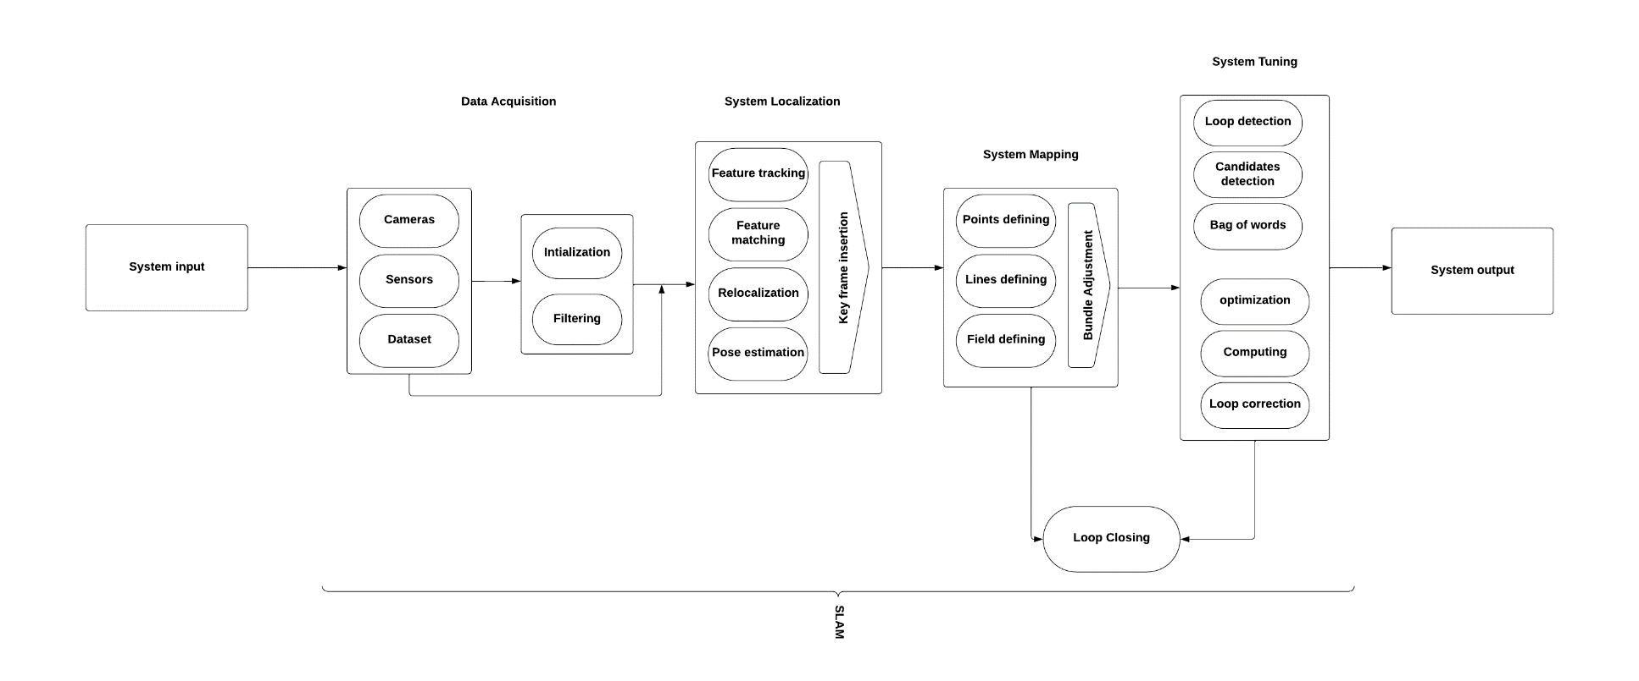

Fig 01: Visual SLAM Architecture

